University of Education, Lahore

Department of

Special Education



Course: IT (COMP1111) Assignment No: 3 Semester: Fall-2021

# Q No 8:

**Now compare the Mean, Median, and Mode and discuss the implications of your findings:**

* **Mode:**

From the observation of mode, we see that the total number of people during accident that are killed or injured are not same or constant. They are increasing or decreasing each and every year. Although only one time the number of injured people in accidents are same in province Baluchistan which is 480 (mentioned in table).

* **Median:**

From the observation of mode, we see that the average of total accidents of people injured or killed in Baluchistan province is quiet low as compared to other provinces every year.

* **Mean/Average:**

From the observation of median, we see that the total number of people during accident that are killed or injured are less than the starting or ending years. From this, we get:

* Starting year = Mostly High/Low.
* Medium= Less or Low.
* Ending year= Mostly Low/High.

# Q No 9:

**Critical review with Graphs:**

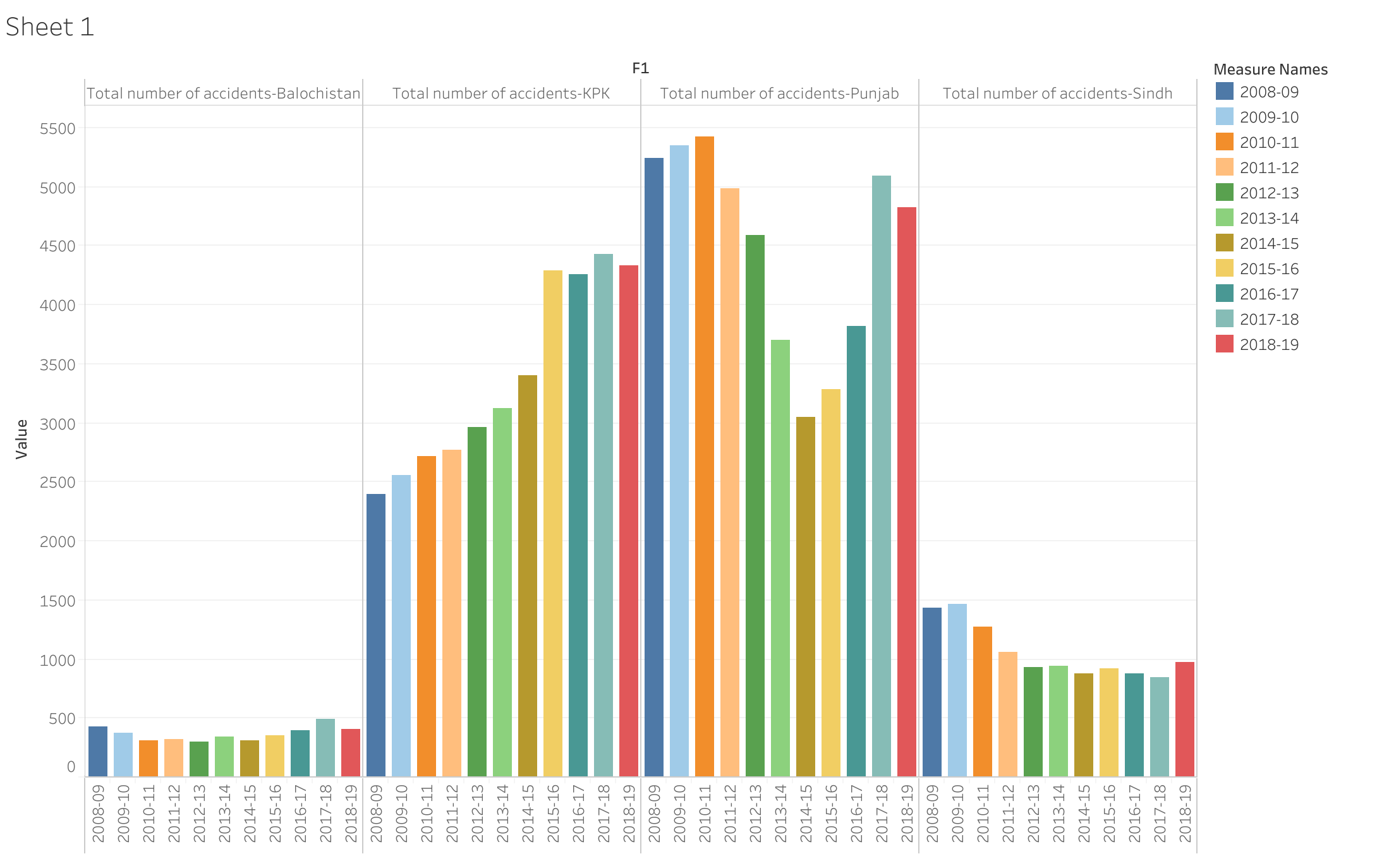

We can see that the highest total number of accidents is in Punjab province and specially in the year 2010-11 as shown in figure. The lowest rate of accidents is in Baluchistan.

* ****Punjab.
* Khyber Pakhtoon khwa.
* Sindh.
* Baluchistan.

# Q No 5:

**Highest number of kills:**

1. Khyber Pakhtoon khwa =5798.

 2) Punjab = 3167.

1. Sindh =1261.
2. Balochistan =542.

